DISHES AND THEIR ALLERGEN CONTENT – Scones

DISHES | 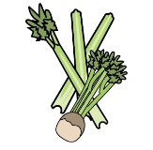 | 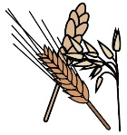 | 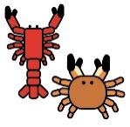 | 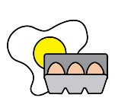 |  | 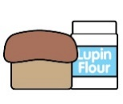 |  |  | 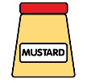 | 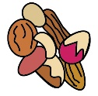 | 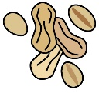 | 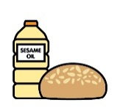
 | Celery | Cereals containing gluten | Crustaceans | Eggs | Fish | Lupin | Milk | Mollusc | Mustard | Nuts | Peanuts | Sesame seeds | Soya | Sulphur Dioxide
Fruit Scone |  | X  Wheat |  | X |  |  | X
Plain Scone |  | X  Wheat |  | X |  |  | X
Cherry Scone |  | X  Wheat |  | X |  |  | X |  |  |  |  |  |  | X
White Chocolate & Raspberry Scone |  | X  Wheat |  | X |  |  | X |  |  |  |  |  | X
Apple & Cinnamon scone |  | X  Wheat |  | X |  |  | X

Review date: |  | Reviewed by: |  |  | You can find this template, including more information at www.food.gov.uk/allergy

