DISHES AND THEIR ALLERGEN CONTENT – Corporate Canapes

DISHES | 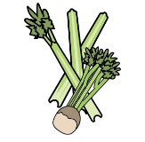 | 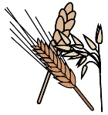 | 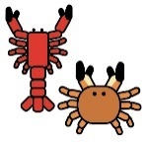 | 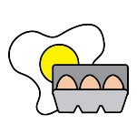 | 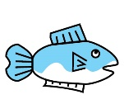 | 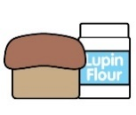 | 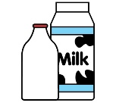 | 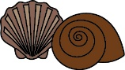 | 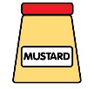 | 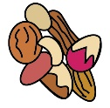 | 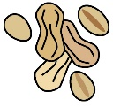 | 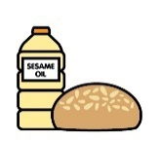 |  | 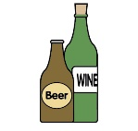
 | Celery | Cereals containing gluten | Crustaceans | Eggs | Fish | Lupin | Milk | Mollusc | Mustard | Nuts | Peanuts | Sesame seeds | Soya | Sulphur Dioxide
Onion Cake, smoked duck breast with bitter orange |  | X  Wheat |  | X |  |  | X
Tomato financier cake, cream of goats cheese, tomato & chives |  | X  Wheat |  | X |  |  | X |  |  | X
Rye bread, chicken rillettes with mustard on white bread |  | X  Wheat  Malt |  |  | X |  |  | X | X |  |  |  |  | X
Blinis, horseradish & lemon cream, marinated anchovy, pink peppercorn & dill |  | X  Wheat |  |  | X |  | X |  |  |  |  |  |  | X
Nordic bread, soft crab cake & avocado mousse |  | X  Wheat  Rye | X |  | X |  | X | X
Biscuit with nuts and cream of roquefort |  | X  Wheat |  | X |  |  | X |  |  | X

Review date: |  | Reviewed by: |  | 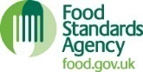 | You can find this template, including more information at www.food.gov.uk/allergy

