DISHES AND THEIR ALLERGEN CONTENT – Traybakes

DISHES | 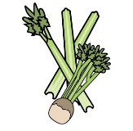 | 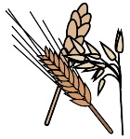 | 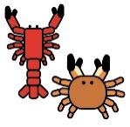 | 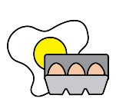 | 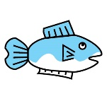 | 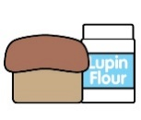 |  |  | 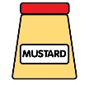 | 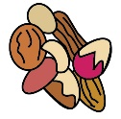 | 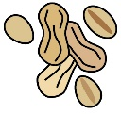 | 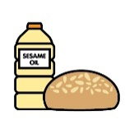
 | Celery | Cereals containing gluten | Crustaceans | Eggs | Fish | Lupin | Milk | Mollusc | Mustard | Nuts | Peanuts | Sesame seeds | Soya | Sulphur Dioxide
Chocolate Brownie |  | X  Wheat |  | X |  |  | X |  |  |  |  |  | X
Lemon Bar Traybake |  | X  Wheat |  |  |  |  | X
Rocky Road |  | X |  | X |  |  | X |  |  | X |  |  | X
Millionaire Shortbread |  | X  Wheat |  |  |  |  | X |  |  | M |  |  | X
Carrot Cake |  | X  Wheat |  | X |  |  | X |  |  | X | X
Vegan Flapjack |  |  |  |  |  |  |  |  |  | X |  |  | X | X
Blueberry Muffin |  | X  Wheat |  | X |  |  | X |  |  |  |  |  | M
Chocolate Muffin |  | X  Wheat |  | X |  |  | X |  |  |  |  |  | X
Iced German Biscuit |  | X  Wheat |  |  |  |  | X
Fifteen |  | X  Wheat  Barley |  |  |  |  | X
Shortbread |  | X  Wheat |  |  |  |  | X
Iced Doughnut |  | X  Wheat |  | X |  |  | X |  |  |  |  |  | X
Natas (Custard Tart |  | X  Wheat |  | X |  |  | X
Raspberry & Coconut Traybake |  | X  Wheat |  | X |  |  | X
Bounty Traybake |  |  |  |  |  |  | X |  |  |  |  |  | X
Mince Pie |  | X  Wheat |  | M |  |  | M |  |  | M |  |  | M

Review date: |  | Reviewed by: |  |  | You can find this template, including more information at www.food.gov.uk/allergy

