DISHES AND THEIR ALLERGEN CONTENT – Build Your Own

DISHES | 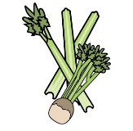 |  | 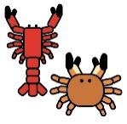 |  | 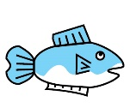 | 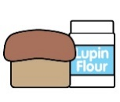 |  |  | 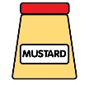 |  |  | 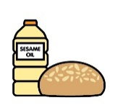
 | Celery | Cereals containing gluten | Crustaceans | Eggs | Fish | Lupin | Milk | Mollusc | Mustard | Nuts | Peanuts | Sesame seeds | Soya | Sulphur Dioxide
Green Salad
Rainbow Coleslaw |  |  |  |  |  |  |  |  | X
New Potato Salad |  |  |  |  |  |  |  |  | X
Beetroot
Cous Cous | X | X  Wheat |  | X |  |  |  |  |  |  |  |  |  | X
Chicken
Streaky Bacon
Feta Cheese |  |  |  |  |  |  | X
Pesto Pasta |  | X  Wheat |  |  |  |  | X |  |  |  |  |  |  | X
Rice Salad |  |  |  |  |  |  |  |  | X
Eggs |  |  |  | X
Grated Cheddar Cheese |  |  |  |  |  |  | X
Spiced Asian Noodle Salad |  | X  Wheat |  |  |  |  |  |  |  | X |  | X | X
Sundried Tomatoes
Hummus |  |  |  |  |  |  |  |  |  |  |  |  |  | X
Kenny’s Caesar Dressing | X |  |  | X | X |  |  |  | X
Kenny’s Honey & Mustard Dressing |  |  |  |  |  |  |  |  | X
Kenny’s French Dressing |  |  |  |  |  |  |  |  | X |  |  |  |  | X
Kenny’s Basil Pesto Dressing |  |  |  |  |  |  | X
Chipotle Dressing |  |  |  | X
Sweet Chilli Dressing
BBQ sauce

Review date: |  | Reviewed by: |  |  | You can find this template, including more information at www.food.gov.uk/allergy

